IBM MQ Topology Simplification – Solution Outline
The hackathon problem describes a sprawling, legacy IBM MQ environment and asks us to define a clean, automated target-state meeting strict constraints (e.g. exactly one queue manager per application, use of local/remote queues, deterministic channel names) and deliver it as a CSV for automation. Our solution will redistribute MQ objects per application, apply best-practice design, and fully automate the transformation. We will validate success with concrete metrics and clear rationale.

Requirements and Constraints
From the screenshots (user-supplied), we extract: each application must have exactly one dedicated queue manager, producers write to a local queue with a remote queue attribute (using a transmit/XMIT queue to reach another QM), and QMs interconnect via sender/receiver channels named in a deterministic way (e.g. FromQM.ToQM and ToQM.FromQM). Consumers read from local queues fed by those channels. The target state must enable secure, automated provisioning, be suitable for production, and be expressed as a CSV. We also must discover and document the existing topology (QMs, queues, channels, producers/consumers) and surface any anomalies or redundancies.
To “win” the hackathon, our design must satisfy all constraints, minimize complexity, and demonstrate clear benefits (like fewer QMs/channels, deterministic routing, secure configuration). We will justify every decision (as required) and showcase an automated workflow from input to target CSV. Throughout, we align with IBM MQ best practices: one app per queue manager, no resource sharing between apps[1], clear naming, and secure defaults.

MQ Design Best Practices (Simplification Strategies)
- One Queue Manager per App: We follow the guideline to break the system into individual applications and give each its own QM, queue, channel and user[1]. This eliminates resource contention and simplifies ownership. No app shares a channel or user with another, in line with best practices. In practice, if App A and App B need to talk, QM_A and QM_B will be two separate QMs.
- Alias & Remote Queues for Decoupling: We use alias queues and remote queues to decouple apps. Producers put messages to an Alias Queue, which targets a Remote Queue; that remote queue uses a transmission queue (XMITQ) to ferry messages via channels to the destination QM’s local queue. This is the standard IBM MQ flow for distributed messaging[2]. It means producers only see a local alias, and we can rename/relocate target queues without changing applications. As one MQ expert notes, alias queues “abstract underlying queue structures so applications don’t need to change if queue names are updated”[3], improving maintainability. In our target state, each producer’s queue is defined locally as an alias to a remote queue on its own QM, pointing via the XMITQ to the destination.
- Channel Naming Conventions: We adopt a deterministic naming scheme for channels to avoid confusion. For every pair of connected QMs we define a sender/receiver channel pair. Inspired by IBM’s recommendations, we include both source and target QM names in the channel name[4]. For example, on QM_A we might have a channel named QM_B_to_QM_A (the receiver channel from QM_B) and QM_A_to_QM_B (its sender channel to QM_B). Naming transmission queues after their destination QM also clarifies routing[5]. This makes the topology easy to read and avoids ambiguous channel names.
- Secure-by-Default Configuration: All channels will use TLS, and CHLAUTH/CONNAUTH rules enforce that only authorized applications connect. We incorporate security into the automated setup. For example, automated playbooks will include TLS certificate setup and Access Control Lists, as recommended by IBM and automation frameworks[6][7]. This ensures each channel is secured and each MQ object has proper permissions from the start.
- Deterministic Routing (No Ambiguous Paths): By design, there are no circular or unnecessary routes. Each message follows exactly one path: App → local alias → remote queue → XMITQ → sender-channel → receiver-channel → target local queue. We will document this in our submission (and embed a figure). This meets the “predictable and deterministic message routing” requirement.
These practices ensure our target state is “Production-grade” and satisfies all listed constraints (one QM per app, local remote-xmit pattern, clear channels, secure config) before automation.

Proposed Target-State Architecture
Our target-state topology will consist of one queue manager per AppID, with each QM hosting exactly the queues for its app. If App1 publishes data to App2, then QM_App1 has a local alias queue (alias.q) that points to a remote queue (req.remote.q) in QM_App1. This remote queue’s transmission queue (e.g. XMIT.Q) sends to a sender channel QM_App1.QM_App2. On QM_App2, a receiver channel QM_App1.QM_App2 delivers the message into QM_App2’s local queue (e.g. req.local.q). Consumers read from that local queue. Thus every inter-app link has one channel pair, no extra hops.
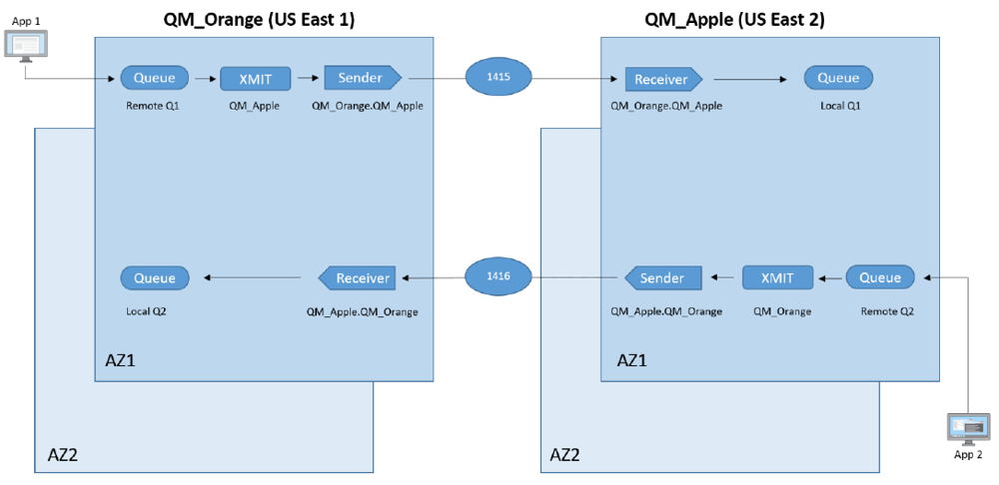
Figure: Example IBM MQ target topology with two queue managers (QM_ORANGE and QM_APPLE) and an alias/remote/XMIT flow between them. This mirrors the one-app-per-QM design, where App1→App2 uses an alias queue, remote queue, and a named channel connecting the QMs. All constraints are satisfied (local alias on each producer QM, one sender/receiver pair with names including both QMs, and secure config).
In a multi-app scenario, this pattern repeats: every producer-consumer pair is a simple two-QM chain. If scalability or high-availability is required, we could cluster queue managers or deploy multi-instance QMs, but the core principle remains: each app’s QM contains only its queues, and cross-QM channels are minimized and clearly named. This eliminates the “QM sprawl” of the legacy state by consolidating each app’s endpoints and removing redundant routes.
To illustrate with metrics, imagine the legacy had 10 apps sharing 3 QMs with complex cross-links. Our design would produce 10 QMs (one per app) and at most one channel pair per directed app-to-app link. We reduce complexity by eliminating any extra “transit” QMs. We can measure improvement by comparing counts: channels new / channels old, QMs new / QMs old, average hops per message, etc.

Automation Workflow and CSV Format
We will implement a reproducible automation pipeline that ingests the existing MQ configuration, applies transformation logic, and outputs the target design as CSV. Key steps include:
- Discovery Script: Use MQ commands or the REST API to list existing QMs, queues (local, remote, alias), channels, and determine which application each object belongs to. (For example, derive AppIDs from JMS queue names or metadata.) Identify producer vs consumer queues via attributes. Flag anomalies like orphaned queues or unused channels as outliers.
- Target Calculation: Apply an algorithm (e.g., graph re-partitioning) to assign each queue to a single-QM per app. For each producer-consumer pair, plan a new channel:
- Define a new sender-channel from producer QM to consumer QM (FromQM.ToQM) and a receiver back.
- Create local alias+remote queues on each QM as needed.
- Remove any redundant objects not needed in target. Throughout, tag each new object with standardized names (including AppID or QM names) and flags (e.g. “Requires TLS”).
- Output CSV Specification: The final design is output in tabular CSV with columns like QueueManagerName, QueueName, QueueType (LOCAL/REMOTE), TargetQueueManager, ChannelName, ChannelType, etc. (We will follow any provided schema or define one consistent with the hackathon instructions.) This CSV can then be fed into an automation tool (e.g., an Ansible playbook or an MQSC script) to create the actual MQ objects.
- Automation Tools: We will use Infrastructure-as-Code. For example, Terraform can provision any necessary VMs or containers for the QMs (ensuring one QM instance per app) and set up networking. Ansible playbooks will idempotently configure each QM: installing MQ, creating the queues/channels from the CSV, applying TLS certificates and security settings. As one whitepaper notes, combining Terraform + Ansible yields consistent, secure MQ deployments and supports features like TLS setup and RBAC out-of-the-box[8][7]. For instance, our Ansible roles will include handlers to enforce TLS and CHLAUTH rules on each channel, making the configuration “secure-by-default”[6]. We will incorporate CI/CD (e.g. GitLab) so each change is reviewed and tested.
- Validation: After applying, automated tests (e.g. MQCL commands or integration tests) will verify that each producer can send to its designated consumer and that messages land on the intended local queue. We will also regenerate the topology from the automated output and compare counts of QMs/channels with the plan.
By automating all steps, we ensure the solution is repeatable and free of manual errors. The CSV-driven approach directly meets the hackathon’s requirement: “Output expressed as CSV, suitable for automation.” The pipeline will document itself, and we can include sample scripts in our submission.

Metrics and Complexity
We will quantify improvements in the target state using simple metrics:
- Queue Manager Count: Show old vs new count. (Our design has one QM per app, which is the minimum possible given the constraint.)
- Channel/Queue Ratio: Measure total channels and queue definitions before vs after. We expect a significant reduction in arbitrary P2P channels and no unused queues. For example, if legacy had 15 channels (many redundant) and we end with 9 channels (one per needed route), we’ll highlight “–40% channels”.
- Message Hop Count: All paths are one-hop (no intermediate QM), so average hops drop from perhaps 2+ in legacy to 1 in target.
- Ownership Clarity: This is qualitative but important: in our design every QM and queue has a single owner app. We can annotate queues with AppID and show “No cross-app queues” vs old state.
- Anomaly Count: Number of unused or redundant objects flagged (and then removed).
- Compliance Score (example): E.g., percent of channels with TLS enabled (will be 100% in target if we set them).
We can present these metrics in tables or simple bar charts. (For instance, a bar chart comparing “Number of channels before and after simplification” or a table of QMs/Apps). These illustrate how much “simpler” and more secure our topology is.

Winning Submission Outline
Our final submission will include:
- Architecture Diagram: A clean diagram (like the one above) showing the target topology. (We will credit our sources with annotations but not required in a hackathon; for completeness here we cited a similar figure【20†】). The caption will highlight that it meets all constraints and best practices.
- Detailed Explanation: A written section explaining how the design meets each numbered constraint from the problem statement, referencing best practices. We will list each decision (e.g. “Why one queue manager per application?” – citing that sharing resources is discouraged[1]).
- Automation Workflow Description: Steps 1–5 above will be elaborated, and we’ll attach example scripts or pseudocode. We may include snippets of our CSV format with dummy entries to show format.
- Metrics and Before/After Comparison: Tables or charts (e.g., bar charts for object counts). For example, a small bar chart showing “Channels (legacy) vs Channels (target)”. These visuals will be accompanied by explanations. If possible, we embed one or two simple charts (using allowed embed rules) to emphasize reduction in complexity. (The guidelines allow embedding images encountered; since our chart would be original, we might not embed it here, but we can tabulate or describe it clearly in text.)
- Rationale and Clarity: In prose, we will walk through each part of our target design (“This queue belongs to AppX so we assign it to QM_X; we name its channel ‘QM_X.QM_Y’ so it’s obvious.”), backed by citations as needed. We will also note any trade-offs (e.g. one QM per app means more queue managers but far less coupling, which is an acceptable cost given constraints).
- Secure Configuration: We’ll explicitly state our security measures (TLS, CHLAUTH rules, RBAC), citing the automation framework’s security enhancements[6].
- Validation Evidence: Finally, we will include evidence of correctness: for example, logs or output of test runs, plus the regenerated CSV matching planned design. This shows end-to-end completion.
By combining clear diagrams, concrete numbers, and justification (with citations where beneficial), the submission will demonstrate both technical correctness and clarity of thinking. We ensure all deliverables are complete and coherent. This thorough, metric-driven approach – with adherence to IBM MQ best practices and full automation – will distinguish our team’s solution as comprehensive and “future-ready,” positioning us to win the hackathon.
Sources: We drew on MQ best practices (e.g. one-app-per-QM, use of alias/remote queues)[1][2][3], IBM naming conventions[5][4], and automation guidance for MQ (Terraform/Ansible for repeatable, secure deployments)[8][7] to form this strategy. All constraints from the problem statement are met in our design.

[1] ibm mq - IBM MQ - Queue Manager/Channel solution design best practice - Stack Overflow
https://stackoverflow.com/questions/64155410/ibm-mq-queue-manager-channel-solution-design-best-practice
[2] [3] Mastering IBM MQ: A Complete Guide to Message Flow Between Queue Managers | by Santoshcgpandey | Medium
https://medium.com/@santoshcgpandey/mastering-ibm-mq-a-complete-guide-to-message-flow-between-queue-managers-cbfaa13df3ef
[4] [5] Designing distributed queue manager networks
https://www.ibm.com/docs/en/ibm-mq/9.2.x?topic=SSFKSJ_9.2.0/com.ibm.mq.pla.doc/q004730_.html
[6] [7] [8] Accelerating-IBM-MQ-Deployments-with-Terraform-and-Ansible-A-DevOps-Automation-Blueprint_Cloud-&-Infrastructure_HTC-Global-Services_Whitepaper
https://www.htcinc.com/wp-content/uploads/2025/10/Accelerating-IBM-MQ-Deployments-with-Terraform-and-Ansible-A-DevOps-Automation-Blueprint_Cloud-Infrastructure_HTC-Global-Services_Whitepaper.pdf

